**Establishment**

*The property consists of 5.124 acres and*

*was purchased in October of 1998. It has*

*undergone a complete metamorphosis with*

*the establishment of food production*

*gardens and the implementation of wildlife*

*habitat restoration. We keep mechanization*

*to a minimum and use a walk behind lawn*

*mower to maintain walking paths or keep*

*invasive plants in check, a string trimmer to*

*groom garden beds and a rototiller to*

*establish new garden beds, revitalize an*

*existing one or control pest populations.*

*After completing treatment for aggressive*

*breast cancer in 2005-2006 I determined it*

*was my good eating habits and using much*

*of my own food that prevented any lymph*

*node infiltration so in 2007 I started selling*

*my excess production at my local farmers’*

*market. I focus on heirlooms for history,*

*flavor and genetic diversity.*

**Where to Find us on the Web**

[*https://www.etsy.com/shop/MeadowviewFarmKY?ref=hdr_shop_menu*](https://www.etsy.com/shop/MeadowviewFarmKY?ref=hdr_shop_menu)

[*https://www.facebook.com/pages/Crestwood-KY/Meadowview-Farm-Natural-Habitat-Gardens-LLC/155500887843244*](https://www.facebook.com/pages/Crestwood-KY/Meadowview-Farm-Natural-Habitat-Gardens-LLC/155500887843244)

[*https://www.kyagr.com/AgBusiness/9110*](https://www.kyagr.com/AgBusiness/9110)

[*http://www.meadowviewfarmandgarden.com/*](http://www.meadowviewfarmandgarden.com/)

[*https://www.pinterest.com/lorilbelling/*](https://www.pinterest.com/lorilbelling/)

[*https://twitter.com/llbelling*](https://twitter.com/llbelling)

**Production Gardens**

* Baked goods made from corn flour,*

*cornmeal and heirloom vegetables.*

* High tunnel and low tunnel gardening*

*for four-season food production.*

* Hand crafted garlic.*

* 4 varieties of Native American corn*

*ground on site.*

* 6 varieties of heirloom dried beans.*

* Heirloom vegetables.*

* Wild crafted items made from fresh and*

*dried plant material grown on property.*

* Reclaimed, repurposed and recycled*

*home décor made from farm operations*

*diverted waste stream.*

* Nursery - Kentucky native plants,*

*cultivars, herbs, succulents and*

*heirloom vegetables.  *

**Habitat Gardens**

* Wildlife habitat restoration of property begun spring of 2003.*

* Repopulating the land with Kentucky native plants to provide food and shelter for wildlife.*

* Allowing natives found naturally on the property to grow and expand their presence.*

* Provide a chemical free environment for wildlife.*

* Educate homeowners about the use of*

*native plants for home scale gardening*

*and habitat restoration.*

**Vintage, reclaimed, recycled + farm grown** ***Meadowview Farm & Natural Habitat Gardens, LLC***

*2005 Meadowview Drive*

*Crestwood KY 40014-9261*

*Phone 502-794-1831*

[*mfnhgllc@gmail.com*](mailto:mfnhgllc@gmail.com)

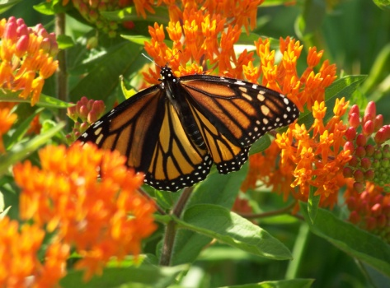

***ON SITE PURCHASES AVAILABLE***

***BY APPOINTMENT ONLY***



**Lori L. Belling**

**Owner/Operator**

**Philosophy**

*We believe in living closer to the land. We advocate and practice sustainable production methods be utilizing native plantings as predator habitat to eliminate the need for chemical applications.*

*We specialize in heirlooms such as rare black popcorn; very rare Native American flour corn and dried beans; value added jams, jellies and baked goods made from heirloom vegetables and ground corn flour or cornmeal.* *We plan for a mix of native plantings for beauty and wildlife support alongside the cultivated production gardens. We continually improve our soil by the addition of organic materials and minimum use of tillage equipment. Our only use of chemicals is for the control of invasive plants that were brought on to the property by previous owners. All garden production is done by hand in addition to harvesting, processing and packaging.*

**Other**

*Farm Box*

*Spring/Summer Fall/Winter*

*Line Item Ordering*

*Baked Goods, Jams, Jellies etc. Ordering*

*\*Visit our website for complete online ordering details*

[*http://www.meadowviewfarmandgarden.com/*](http://www.meadowviewfarmandgarden.com/)

***Garlic Bed***

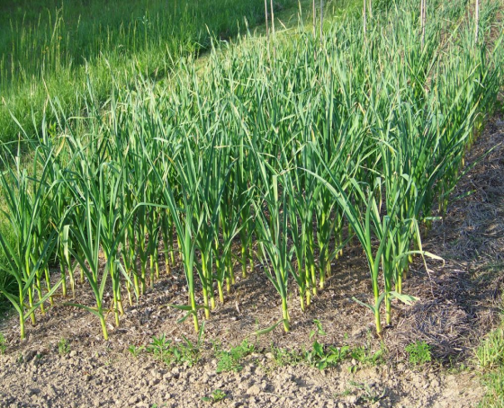

**Sustainability**

*Everything taken off the land is put back by use of composting. Grass clippings and straw are effective mulch and greatly reduce the need for weeding while providing soil stability through temperature and moisture moderation and pest deterrence. All plant material benefits from the use of mulch by adding organic matter back into the soil.*

**Kentucky Proud**

*Kentucky Proud Program participant Certificate No. 1034.*



**Nursery License**

*Kentucky Nursery License No. 162 A.*

**Property Certifications**

*Bee Friendly Farming Certified*

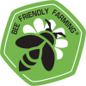

*GAP Certified 04/26/2008*

****

*Monarch Waystation Number 1861.*

****

*The National Wildlife Federation certifies*

*us as a Backyard Wildlife Habitat Certificate No. 59237.*

****

*The Urban Wildlife Sanctuary Program by The Humane Society of the United States certifies us as an Urban Wildlife Sanctuary Certificate No. 735.*

**Memberships**

*Kentucky Native Plant Society - Lifetime Member*

*Seed Savers Exchange*

*Wild Ones*

***Beebalm***

